Primero instalar los complementos

Configurar: char-ever_sql
VC++Directories
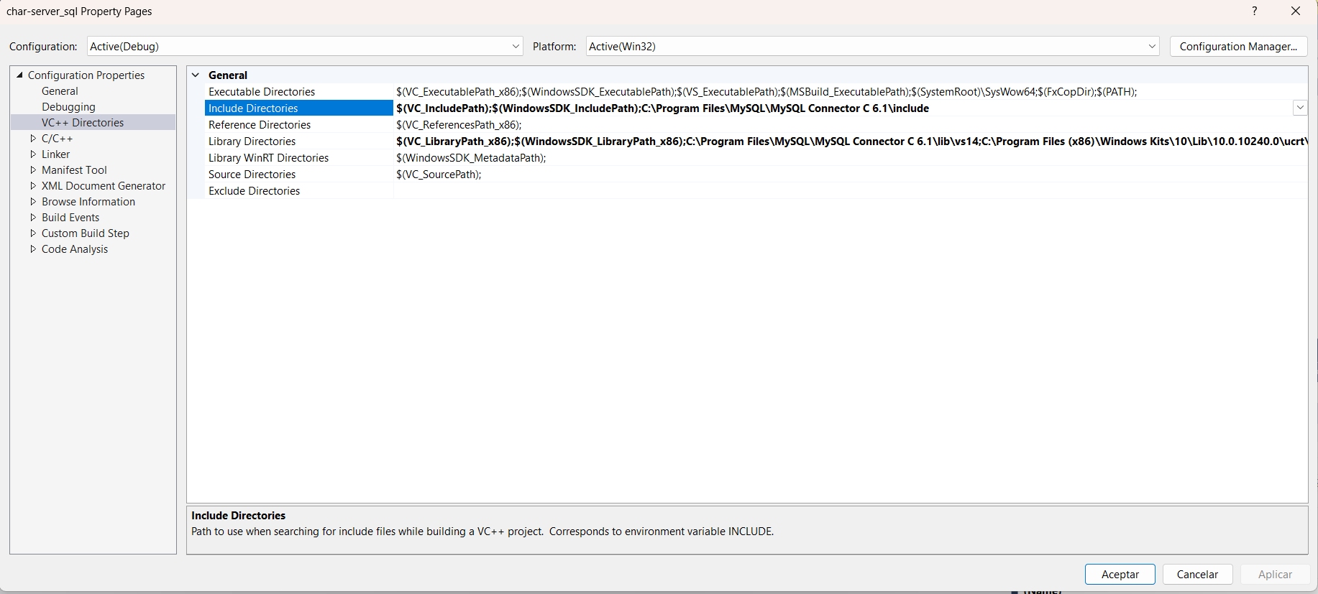

Include directories: $(VC_IncludePath);$(WindowsSDK_IncludePath);C:\Program Files\MySQL\MySQL Connector C 6.1\include
Library Directories: $(VC_LibraryPath_x86);$(WindowsSDK_LibraryPath_x86);C:\Program Files\MySQL\MySQL Connector C 6.1\lib\vs14;C:\Program Files (x86)\Windows Kits\10\Lib\10.0.10240.0\ucrt\x86;C:\Program Files (x86)\Microsoft Visual Studio 14.0\VC\lib

Linker > input
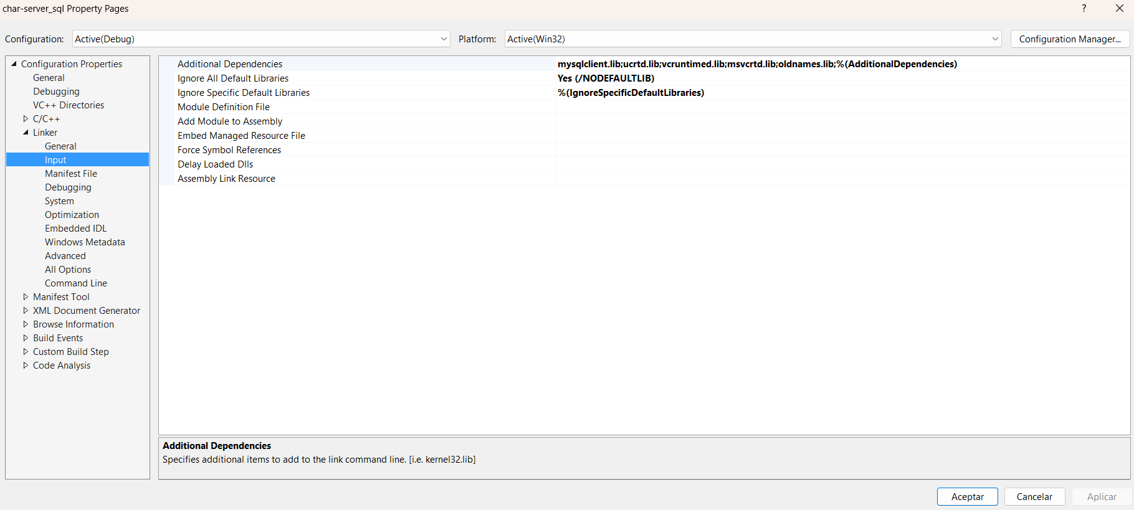

Additional Dependencies: mysqlclient.lib;ucrtd.lib;vcruntimed.lib;msvcrtd.lib;oldnames.lib;%(AdditionalDependencies)

